

Brewcraft Ltd
(New Zealand, Australia, USA, & UK)

WATER PRESS LANCMAN™
Models: VS-A , VSP-A, VSPI-A

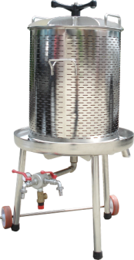 | 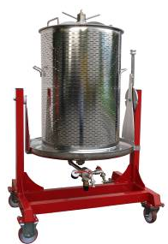 | 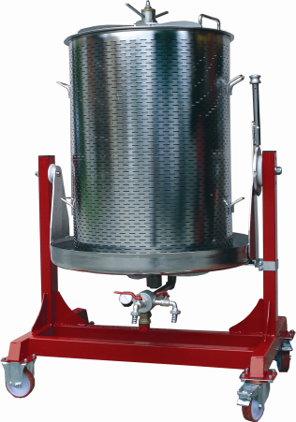

 | INSTRUCTIONS FOR SAFE USE,  MAINTENANCE and SERVICING

Instruction are intellectual property of company Brewcraft Ltd
Criminal offence is every propagating and copying of instructions without knowledge of owner!

WARNING

THIS MACHINE CAN BE USED
ONLY BY A PERSON WHO HAS BEEN ACQUAINTED WITH THE INSTRUCTIONS FOR USE AND
SAFETY WARNINGS!

WHEN HANDING OVER THE PRODUCT TO A THIRD PARTY THE INSTRUCTIONS FOR SAFE USE, MAINTENACE AND SERVICING MUST ALSO BE HANDED OVER!

TABLE OF CONTENTS

1. A WORD TO THE PURCHASER - USER 3
2. SERVICING AND ORDERING SPARE PARTS 3
4. INTENDED FUNCTION AND TECHNICAL DATA 3
5. SAFETY WARNINGS ON THE MACHINE 3
6. SAFETY IN USE OF THE MACHINE 3
7. DESCRIPTION OF THE MACHINE AND ITS WORKING SYSTEM 3
8. INSTRUCTIONS FOR USE - PRESSING 3
9. TECHNOLOGY OF PRESSING 3
10. TRANSPORTATION AND STORAGE OF THE MACHINE 3
11. APPLICATION AREA FOR THE MACHINE 3
12. INSTRUCTIONS FOR SAFE MAINTENANCE 3
13. Spare parts description for modelsLANCMAN VS-A 3
14. Spare parts picture for models LANCMAN VS-A 3
15. Spare parts description for modelsLANCMAN VSP-A, VSPI-A 3
16. Spare parts picture for models LANCMAN VSP-A, VSPI-A 3
17. Spare parts description for models 3
LANCMAN VS-A 55, VS-A 80, VSP-A 80, VSPI-A 80 3
(water system) 3
18. Spare parts picture for models LANCMAN 3
VS-A 55, VS-A 80 3
(water system) 3
19. Spare parts description for models LANCMAN 3
VS-A 120, VSP-A 120, VSPI-A 120, VSP-A 170, VSPI-A 170, 3
VSPI-A 250 3
(water system) 3
20. Spare parts picture for models LANCMAN 3
VS-A 55, VS-A 80 3
(water system) 3
21. INSTRUCTIONS FOR SERVICING AND TESTING 3
22. DISMANTLING AND REMOVAL OF THE MACHINE (TIPPING) 3
23. TROUBLESHOOTING 3
24. KIT REGISTER 3

Declaration of Conformity


EEC DECLARATION OF CONFORMITY nr.02/L80

As manufacturers we declare with full responsibility that the machine mentioned below is produced in accordance with the Regulations, listed bellow.
This statement is not valid following unauthorized modifications to the machine.

LANCMAN™ WATER PRESS

typ: VS-A size: 55, 80, 120

typ: VSP-A size: 80, 120, 170, 250

typ: VSPI-A size: 80, 120, 170, 250

Serial number and production year: on machine’s plate

The machine is produced in accordance with the demands of these regulations:
REGULATION | STANDARD
Directive, Machinery Safety , MD 98/37/EC | SIST EN 292-1  SIST EN 292-2:1996/A1 2000  SIST EN 1050
Pressure equipment directive, PED 97/23/ES (Procedure according to module A)
Regulation (EC) No 1935/2004 of the European Parliament and of the Council of 27 October 2004 on materials and articles intended to come into contact with food

1. A WORD TO THE PURCHASER - USER
We thank you for the trust you have shown us by buying our product. We are convinced that you will be pleased with it.
Before first use one must thoroughly read and comprehend the instructions for safe use and maintenance, where one will discover the intended function, functionality and machine’s work environment. The instructions are written in a way so that one is acquainted with all the required activities even before the machine’s first use, maintenance and regular servicing.
In case the product would be handed over to a third party, the instructions for safe use, maintenance and servicing must also be handed over.
When reading the instructions, one must pay extra attention to the chapters and paragraphs that are labelled with this mark.
Beside the text in the instructions this mark especially emphasises the importance of records in a definite chapter of the instructions.

Every partial or complete reproduction of these instructions, text and pictures is a criminal offence.

2. SERVICING AND ORDERING SPARE PARTS
Servicing and troubleshooting during the warranty period and afterwards will be performed by:

Brewcraft Ltd or their authorised representatives

When ordering spare parts one must always give the following information:
- name of machine
- type of machine
- serial number of machine
- year of production of machine
All the data required for ordering spare parts is written on the plate or on the permanent label that is placed on the machine.

3. INTENDED FUNCTION AND TECHNICAL DATA
The press is used for obtaining must or juice by pressing various sorts of ground fruit, for pressing slime extract (using a filter bag) with the effect of water pressure from the water supply network. The machine is not for professional use. Every use outside the described intended function is treated as an unintended use, for which the manufacturer does not guarantee safety and functionality.
All modifications or replacements of the press’s original components preclude the manufacturer's warranty for the safety and functionality of the machine.
The skin of the press is sensitive to mechanical damage, such as cuts, perforations etc.
Mechanical damage is not covered by the warranty!

Technical data:

Type: VS-A
Name: | WATER PRESS LANCMAN
Type: | VS-A 55 | VS-A 80 | VS-A 120
Dimensions (mm): | 600x600x950 | 560x560x1250 | 650x650x1250
Basket size: | 55 L | 80 L | 55 L
Cover material: | X5CrNi1810 (stainless steel)
Lid material: | X5CrNi1810 (stainless steel)
Basket material: | X5CrNi1810 (stainless steel)
Highest allowed pressure: | 3,0 bar
Utilisation pressure: | 2,5 bar
Pressure regulation: | 3,0 bar – safety valve
Charging: | water supply network 3 bar
Total weight: | 35 kg | 40 kg | 55 kg
Production date: | SEE THE DECLARATION OF CONFORMITY

Type: VSP-A
Name: | WATER PRESS LANCMAN
Type: | VSP-A 80 | VSP-A 120 | VSP-A 170
Dimensions (mm): | 800x870x1300 | 800x870x1300 | 800x870x1300
Basket size: | 80 L | 120 L | 170 L
Lid material: | EN: X5CrNi1810 (stainless steel)  W.Nr. 1.4301
Cover material: | EN: X5CrNi1810 (stainless steel)  W.Nr. 1.4301
Basket material: | EN: X5CrNi1810 (stainless steel)  W.Nr. 1.4301
Fixed nut material: | PVC | stainless steel | stainless steel
Cart material: | METALLIC FURNITURE PIPES
Highest allowed pressure: | 3,0 bar | 3,0 bar | 2,5 bar
Utilisation pressure: | 2,5 bar | 2,5 bar | 2,4 bar
Pressure regulation: | 3,0 bar – safety valve | 3,0 bar – safety valve | 2,5 bar – safety valve
Charging: | water supply network 3 bar | water supply network 3 bar | water supply network 2.5 bar
Total weight: | 64 kg | 76 kg | 83 kg
Production date: | SEE THE DECLARATION OF CONFORMITY

type: VSPI-A
Name: | WATER PRESS LANCMAN
Type: | VSPI-A 80 | VSPI-A 120 | VSPI-A 170 | VSPI-A 250
Dimensions (mm): | 800x870x1300 | 800x870x1300 | 880x900x1350 | 880x900x1600
Basket size: | 80 L | 120 L | 170 L | 235 L
Lid material: | EN: X5CrNi1810 (stainless steel)  W.Nr. 1.4301
Cover material: | EN: X5CrNi1810 (stainless steel)  W.Nr. 1.4301
Basket material: | EN: X5CrNi1810 (stainless steel)  W.Nr. 1.4301
Fixed nut material: | PVC | stainless steel
Cart material: | METALLIC FURNITURE PIPES
Highest allowed pressure: | 3,0 bar | 3,0 bar | 2,5 bar | 2,5 bar
Utilisation pressure: | 2,5 bar | 2,5 bar | 2,4 bar | 2,4 bar
Pressure regulation: | 3,0 bar – safety valve | 3,0 bar – safety valve | 2,5 bar – safety valve | 2,5 bar – safety valve
Charging: | water supply network 3 bar | water supply network 3 bar | water supply network 2.5 bar | water supply network 2.5 bar
Total weight: | 64 kg | 76 kg | 83 kg | 105 kg
Production date: | SEE THE DECLARATION OF CONFORMITY

4. SAFETY WARNINGS ON THE MACHINE
The machine is made in accordance with standards that allow the manufacturer to label it with CE. However, the machine causes some perils, and therefore there are, in accordance with preserving machine’s functionality, warning inscriptions and symbols – pictographs - on it.

Explanation of the warning symbols (pictographs) on the machine:

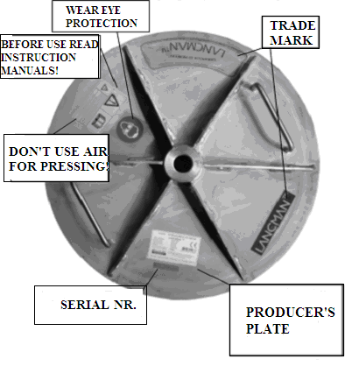

5. SAFETY IN USE OF THE MACHINE
- The machine can be used only by professionally trained and healthy persons older than 18 years.
- While operating the machine must not be moved or displaced.
- While operating the machine must not be cleaned or repaired.
- For the user's safety the machine must not be charged with air.
- However, it is necessary to give an assurance that the outlet connector of the safety valve is unhindered!
- Never press without the lid!
Before first use of the machine one must:
- carefully read and comprehend the contents of these instructions,
- look for all warnings, symbols and inscriptions on the machine, and discover their meaning in these instructions, Chapter VII,
- read the instructions and get to know all parts of the machine and their functions, Chapter IV,
- pay attention to the instructions before every use of the machine.
Before every use of the machine one must:
- pay attention to the instructions before first use of the machine.
- check the machine before every use; the description of the procedure can be found in Chapter VI,
- check that all parts of the machine are in prime condition,
- put the machine on firm, level ground that is not slippery and allow at least 2m2 surface for use,
- pay attention the to machine's biggest incline which must not be bigger than 1 degree of arc, and the lined element must not be taller than 10mm,
- make sure that the illumination of the machine and work space is sufficient (at least 150 Lux),
- people who work with the machine must wear tight clothes, protect long hair and wear no jewellery, ties or similar items,
- make sure that working with the machine threatens nobody in the vicinity and that there are no children nearby,
- make sure that work space surroundings are tidy and not cluttered with other items,

Testing the tightness of the press:
Before first use, and at the beginning of every season, one must check the tightness of gaskets when the press is still empty. Connect the press to the network. This is done similarly as before the beginning of pressing; the only difference is that this time the basket’s contents must be empty. Close the lid and screw the nut. Open the water valve and fill the skin with water. Leave the water running until the skin begins to stretch slowly. When doing that make sure that the skin cannot touch the basket. When pressing with an empty press the skin can get damaged, and the warranty doesn’t cover that. Even before the skin gets to the basket and achieves 0.5 bar of pressure one must stop pressing and pour the water out. When the water is completely out one must open the lid and check the connectors of the flange that has both top and bottom rubbers. If the junctions are dry tightness is assured, but otherwise the flange must be fixed.

6. DESCRIPTION OF THE MACHINE AND ITS WORKING SYSTEM
Picture and description of machine

The press is a machine that uses water pressure as the source of energy for its operation. The press works according to the principle of pressing previously ground fruit against the
press basket’s wall. This pressure gives us the energy needed for pressing ground fruit.
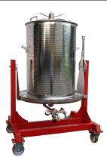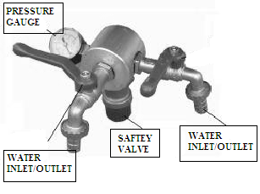
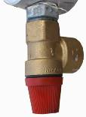
For efficient pressing 2.5 bar should be sufficient. One can obtain this pressure by connecting to the water supply network. The membrane is built axially in the centre of the press and fixed to the bottom of the reservoir by a flange and six screws. The pressure connector is on the bottom side of the reservoir, as are the pressure gauge and safety valve with water release drop at 3.0 bar – connecting-measuring-safety unit. The connecting-measuring-safety unit (in the picture) is a combination of a pipe nozzle, that measures 1/2”, a ball-bearing tap, connecting the chamber made of aluminum, pressure gauge, safety valve with a spring, discharged ball-bearing tap, and a supplementary part for water outlet. The bottom side of the connecting chamber has an engraved inner pipe coil for fixing the unit on the attaching pipe of the press. The water pipe has a supplementary part for the flexible pipe screwed on, which can be attached to the water supply network. The upper side of the chamber has a pressure gauge with 0-4 bar wide measuring area attached. There is a spring safety valve built into the back side of the chamber. In case the pressure rises, this valve is used as a safety device that causes a no-energy state of the machine.

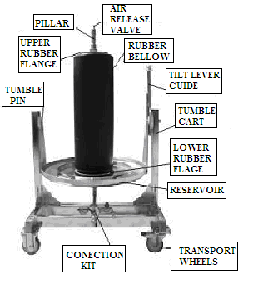
The coiled reel, which also allows the water into the membrane, has a fixed air- release valve on the top of the upper end. As one can see in the picture, the membrane is bilaterally pinned with the flange. The lower flange is screwed on to the reservoir with six screws, and the upper is held by a steel lid that is attached through a coiled reel and fixed with a coiling nut. Through the fixed membrane one puts the peripheral perforated metal sheet in the locating ring of the reservoir (see the picture). Through the coiled reel one places the lid. To do that, one must sit on the peripheral metal sheet and on the upper flange of the pressure membrane. To fix the lid, use the coiling nut, which must be screwed on to the coiled reel as tightly as possible (left rotation). The power needed in this process can be achieved by hand. Additional tools are not necessary.
.

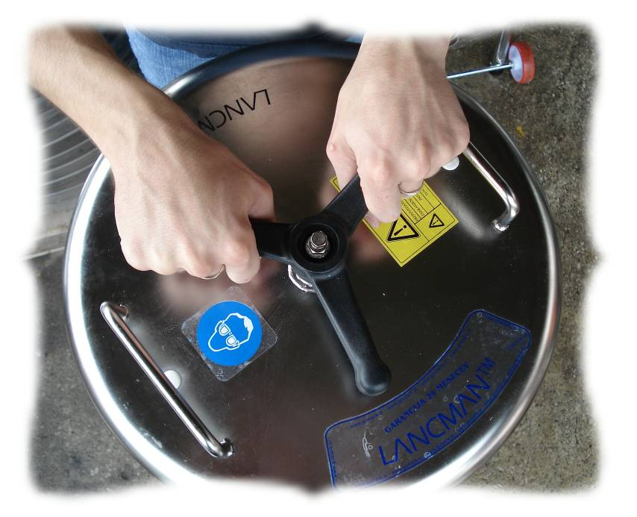

7. INSTRUCTIONS FOR USE - PRESSING
One must test the properly set and prepared (cleaned) press (according to the instructions before first and every use). The activity test must be carried out in accordance with the instructions for servicing and testing, Chapter VI. Before filling the basket (peripheral perforated metal sheet), one must unwind the coiling nut and take off the lid. One sets the basket of the press in the middle of the reservoir, exactly between the centring plates that are welded on the reservoir. Inside the basket should be inserted the net that is supplied which assists with easier emptying of the basket. Then one fills the space between the rubber membrane and peripheral metal sheet (basket) with ground fruit. One must be careful to distribute the mass evenly, for otherwise the pressure can be disrupted and the pressing of the ground fruit can be uneven.

When filling, don’t squeeze the ground fruit as the utilisation might be lower. When filling, the toggle valve from the reservoir must be open, otherwise the capacity of the press might be smaller. It is necessary to enable dedusting of the press. The contents of the press can always be filled up to the top (utmost edge of the peripheral metal sheet).

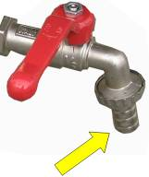
One must always perform full pressing, when the press is filled to the upper edge, as otherwise the skin can get damaged, and this is not covered by the warranty. Despite the lack of fruit in the end, one can achieve the basket's maximum capacity in many ways (adding the already pressed fruit, reducing basket's capacity by skin’s volume amplification). Close the outlet valve on the top of the coiled reel and replace the lid, as the picture demonstrates. The lid should be fixed by screwing the coiling nut on the coiled reel. The coiling nut must be never screwed with tools, , but should be tightened by hand. The tap for water application must be attached with the flexible pipe, which must then be attached to the water supply network. Open the ball-bearing tap for water application on the unit and the tap connected to the water supply network. Afterwards the pressing can be set in motion. The press’s membrane needs some time to fill, so one may notice water leakage in the air-release valve. When this occurs, one must completely close the valve. There will be high pressure created in the system, and one can measure it with the pressure gauge. If the pressure rises above 3 bar, the safety valve will open and some quantity of water will flow out of the system. By closing and opening the water tap one can avoid water leakage through the safety valve by constantly monitoring (with the pressure gauge) the level of pressure in the system. One can relieve the pressure by closing the water pipe and opening the ball-bearing tap on the unit and the air-release valve on the coiled reel. When pressure drops to 0.0 bar over pressure, one must unwind the nut and take off the lid. One must firstly loosen the pressed fruit, lift the peripheral metal sheet from the reservoir and clean it. If the additional net was used in pressing, the removal is much easier if one uncovers the net. After final pressing, one must thoroughly clean the press. The press should be cleaned with nothing but clean water. Stainless material can be cleaned with detergents that are used in housework, but the extending skin must be cleaned with nothing else but water.

Emptying the basket of the press
With left hand one must pull the cap on the small handle of the plug; first up and then right.
With one hand one must hold the small handle of the lid and pull towards oneself, so the press will be turned over to a laying position. Meanwhile, one must also be careful that the cork is clasped on the back groove. Then one must unwind the tension nut, remove the lid and empty the basket of the press. When doing that, one can use the net that was placed in the press before the process of pressing.

When filling and emptying the press, one must use protective gloves, as moist skin is highly exposed to cuts.

When emptying the basket, one must never lift the filled basket. It must always be previously emptied with the additional net. However, if one decides to lift the basket, one must always grasp it at places that were prepared especially for such act (handles of the basket).

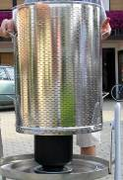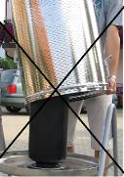

The press can be used in combination with the additional bag for pressing lees.

When doing that, one must use original bags of the right size, as otherwise the skin can become damaged.

8. TECHNOLOGY OF PRESSING
SOLID FRUIT
When pressing solid fruit (apples, pears …), one must grind the fruit with a mill (drum mill, mixing mill). Ground fruit can then be thrown in the basket of the press without any previous squeezing. For better pressing and easier emptying of the basket, one can use the additional net. The process of pressing ground fruit lasts app. 30 min (depending on the desired utilisation). The process of pressing grapes lasts from 30 min, and has no upper limit. One must then place a green safety bag on the basket, so that during pressing the ground fruit won’t splash around.

GRAPES
Before pressing the fruit, grinding of grapes (grape mill) is recommended. Stemming is not recommended, for the system of pressing on the skin up to 3 bar doesn't injure stems. Stems assure good drainage and by that quicker outflow and better pressing utilisation.
Due to more efficient pressing, one is recommended to leave ground dark grapes for three days so that the berries can excrete slime. By that the pressure utilisation increases.
With white grapes one is recommended to use enzymes for more efficient pressing. Enzymes allow faster extraction of the berries’ slime and prevent the grapes from oxidising. Before starting this process, one should discuss the matter with an expert in a specialised store or with a merchant who has participated in the process of purchasing the press.
A green safety bag must be placed on the basket so that during pressing the ground fruit won’t splash around.

PRESSING THE LEES
For pressing the lees one must use a bag that was prepared especially for that use. One is recommended to use a bag of the right size (original is the best), so that the skin of the press or the bag for lees does not get damaged during pressing.

The bag must be placed in such a way that the skin cannot touch the basket of the press. In this way one will prevent the skin acquiring mechanical injuries.

To achieve high quality of wine it is necessary to excrete the mucus of the must. With the outflow of pure must there are leavings that amount to 20-30%. This is slime extract that we can either throw away or leave for further sedimentation.
When filtering lees or the slime extract, one must put a specially arranged filter bag in the press. A portion of diatonic soil must be added to the lees and then the combination must be well mixed a couple of times. Then the bag must be filled with lees. The entry hole must be closed so that during pressing the lees is prevented from falling out. After final pressing the bag must be carefully pulled out of the press. The filter bag must be thoroughly cleaned after every filtration.

The bag that one takes from the press must be inverted outwards, so that the entire sediment that remained in the bag falls out (the bag must be turned in a similar way as one turns the pullover). The entire inner surface of the bag that is inverted outwards must be thoroughly washed with a jet of water. Then the bag can be inverted to the original state, and the outer surface also washed with a jet of water. Afterwards one must leave the bag to dry. So the bag is prepared for its next use. With first use the bag changes its colour from white to brown and remains that colour even after washing.

For more advice on pressing the lees ask the experts.

9. TRANSPORTATION AND STORAGE OF THE MACHINE

The total weight of the machine is given in the table, Chapter IV. One is allowed to move the machine, but transportation is only possible when not in use and it must also be empty. The press’s weight allows simple movement that can be carried out by two adults. After it has been used, cleaned and dried, the machine must be stored in a dry and ventilated place where there are no fertilizers. Thorough cleaning is important, as the amount of moisture depends on it. Over a certain period of storage, possible dirt on the machine will attract moisture.
After the season of pressing, one should prepare the press for longer storage. Meanwhile, one must make sure that the membrane is in the original state, with no pressure. The lifetime of the press will in that way be essentially extended.

10. APPLICATION AREA FOR THE MACHINE

The machine can be used by only one person at a time, and this person must always occupy the position, shown in the picture above.

11. INSTRUCTIONS FOR SAFE MAINTENANCE

Basic maintenance
- maintenance should be carried out only by professionally trained personnel or an authorized service company,
- maintenance and cleaning of the machine can be carried out only with the water tap fully closed and air-release valve fully open,
- before and after every use the machine must be thoroughly cleaned and dried,
- with every type of maintenance one must use adequate tools and protective gloves,
- after every maintenance check one must perform the activity test,
- when cleaning one must use detergents that are used in the food industry,
- the cleaned and dried press must be stored in a dry place where it will be stored until its next use or season,
- minimal contact of the press with grease and oil must be assured.

Maintenance of the connected water supply network
- all constituent parts of the system must be monitored on a regular basis and replaced if possible problems occur or the lifetime of the machine has passed,
- maintenance and cleaning of the system can only be carried out, when the system is inoperative, with the water tap fully closed and the air-release valve fully open,

Basic spare parts of the machine
- tap for water application
- pressure gauge (0-4 bar),
- safety valve (3.0 bar),
- rubber pressure membrane,,
- Screws for screwing the flanges of the membrane,
- headrace and water outlet supplementary part,
- peripheral perforated metal sheet,
- handles for lifting the peripheral metal sheet,

12. Spare parts description for modelsLANCMAN VS-A

Pos. | Descritption | qty | code
1. | Washer M12 | 2 kos
2. | Wheel Poliamid | 2 kos
3. | Press reservoir (see declaration) typ:  - vs-a 55 L  - vs-a 80 L  - vs-a 120 L | 1 kos
4. | Wheel fixing studs | 2 kos
5. | Press basket – size (see declaration):  - vs-a 50 L  - vs-a 80 L  - vs-a 120 L | 1 kos
6. | Basket cover – size (see declaration):  - vs-a 55 L  - vs-a 80 L  - vs-a 120 L | 1 kos

13. Spare parts picture for models LANCMAN VS-A

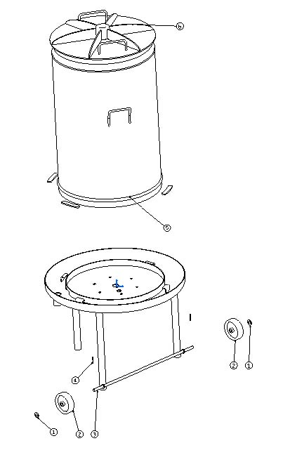

14. Spare parts description for models LANCMAN VSP-A, VSPI-A

Pos. | Descritption | qty | code
1. | Wheel rotirajoče – poliamid | 2 kos
2. | Hex nut M8 | 8 kos
3. | Washer M8 | 8 kos
4. | Screw M8x16 | 8 kos
5. | Wheel fixed – poliamid | 2 kos
6. | Tumble cart(see declaration) typ:  - vsp-a 80  - vsp-a 120  - vsp-a 170  - vsp-a 250  - vspi-a 80  - vspi-a 120  - vspi-a 170  - vspi-a 250 | 1 kos
7. | Hex nut M10 | 2 kos
8. | Hex nut M16 | 2 kos
9. | Timble flange | 1 kos
10. | Screw M10x30 | 2 kos
11. | Washer PVC | 1 kos
12. | Screw M16x95 | 2 kos
13. | Washer PVC | 2 kos
14. | Hex nut M16 | 2 kos
15. | Timble cap | 1 kos
16. | Press basket – size (see declaration):  - 80 L  - 120 L  - 170 L  - 250 L | 1 kos
17. | Basket cover – size (see declaration):  - 80 L  - 120 L  - 170 L  - 250 L | 1 kos
18. | Timble lever | 1 kos
19. | Timble spring | 1 kos
20. | Screw M16x85 | 1 kos
21. | Timble cover | 1 kos
22. | Press reservoir – size (see declaration):  - 80 L  - 120 L  - 170 L  - 250 L | 1 kos
21. | Tible safety rode | 1 kos

15. Spare parts picture for models LANCMAN VSP-A, VSPI-A

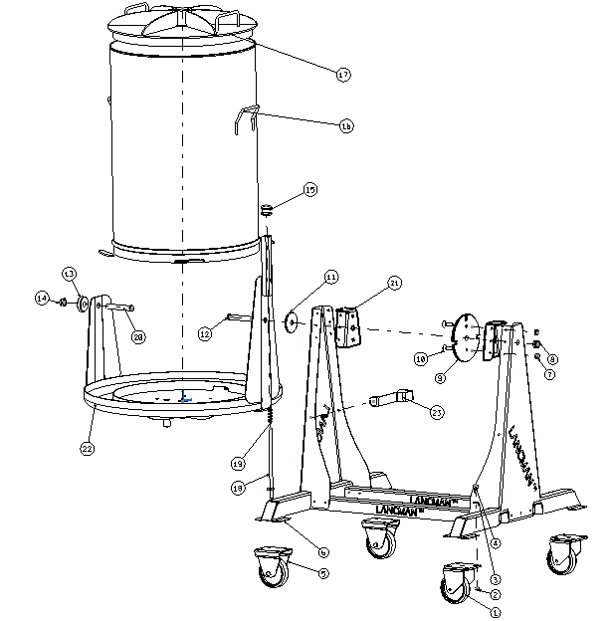

16. Spare parts description for models

LANCMAN VS-A 55, VS-A 80, VSP-A 80, VSPI-A 80

(water system)

Pos. | Descritption | qty | code
1. | Water pipe ½' | 1 kos
2. | Pressure gauge 0-4 bar | 1 kos
3. | Water supply unit | 1 kos
4. | Water pipe ½' | 1 kos
5. | Safety valve– 3 bar | 1 kos
5. | Pipe ½' | 1 kos
7. | Pipe knie ½' | 1 kos
8. | Hex nut G½'x30 | 1 kos
9. | Seal | 1 kos
10. | Ring | 1 kos
11. | O ring 20x3 | 1 kos
12. | Ring | 1 kos
13. | Pin | 1 kos
14. | Main rod – size (see declaration)  - 55 L  - 80 L | 1 kos
15. | Release air valve | 2 kos
16. | Ring | 2 kos
17. | O ring 20x3 | 1 kos
18. | Flange up-lower | 1 kos
19. | Hex nut M6 | 2 kos
20. | Flange 6 holes - lower | 1 kos
21. | Screw M6x20 | 6 kos
22. | Rubber bellow - size(see declaration)  - 55 L  - 80 L | 1 kos
23. | Flange up-upper | 1 kos
24. | Hex nut – upper M20 | 1 kos
26. | Hex nut - cover | 1 kos

17. Spare parts picture for models LANCMAN

VS-A 55, VS-A 80

(water system)

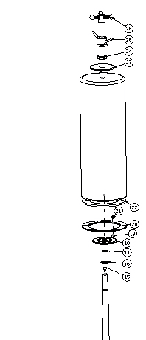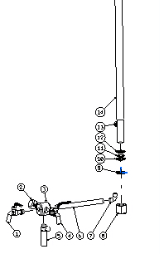

18. Spare parts description for models LANCMAN

VS-A 120, VSP-A 120, VSPI-A 120, VSP-A 170, VSPI-A 170,

VSPI-A 250

(water system)

Pos. | Descritption | qty | code
1. | Water pipe ½' | 1 kos
2. | Pressure gauge 0-4 bar | 1 kos
3. | Water supply unit | 1 kos
4. | Water pipe ¾'
5. | Safety valve– size stiskalnice (see declaration):  - 120 L – 3 bar  - 170, 250 L – 2.5 bar | 1 kos
6. | Pipe ½' | 1 kos
7. | Pipe knie ½' | 1 kos
8. | Hex nut M30x2 | 1 kos
9. | Seal | 1 kos
10. | Ring | 1 kos
11. | O ring 30x3 | 1 kos
12. | Ring | 1 kos
13. | Pin | 1 kos
14. | Main rod – size (see declaration)  - 120 L  - 170 L  - 250 L | 1 kos
15. | Release air valve | 1 kos
16. | Ring | 2 kos
17. | O ring 30x3 | 1 kos
18. | Flange up-lower | 1 kos
19. | Hex nut M10
20. | Flange 6 holes - lower  – size (see declaration)  - 120, 170 L  - 250 L | 1 kos
21. | Screw M10x30 z vgrez.glavo | 6 kos
22. | Rubber bellow - size(see declaration)  - 120, 170 L  - 250 L | 1 kos
23. | Flange up-upper | 1 kos
24. | Hex nut– upper M30x2 | 1 kos
25. | Hex nut - cover | 1 kos

19. Spare parts picture for models LANCMAN

VS-A 55, VS-A 80

(water system)

The press is electro polished to the highest lustre. Therefore the user is provided with easier cleaning, and it also assures better hygiene and extends the lifetime of stainless steel.

Hydraulic connection diagram

1 – ball-bearing taps for the application of water in to the system with the supplementary part for the flexible pipe,
2 – connection chamber
3 – air-releasing ball-bearing tap with the supplementary part for water outlet,
4 – service pipe to the membrane
5 – pressure membrane
6 – pressure gauge, 0-4 bar
7 – safety valve with spring, 3.0 bar

20. INSTRUCTIONS FOR SERVICING AND TESTING
The machine needs regular checks to prevent the machine from acquiring damage that could occur because of the machine’s inappropriate use. Irregularities can occur because of system errors or human factor in placement and at use.

The following servicing of the machine must be performed:
- checkup before first use
- checkup before every use
- annual checkup before the pressing season,
- Periodic checkups from an occupational safety point of view.

Checkup before first use:
- basic visual checkup of the machine’s condition,
- water supply network activity checkup and air-releasing ball-bearing tap control
- checkup of the screws for fixing the membrane and other screws,
- machine stability checkup.

Checkup before every use:
- screw junctions checkup,
- Safety valve activity checkup,
- visual superficial checkup of the membrane.

Annual checkup before the pressing season:
- checkup of the peripheral metal sheet and welded spots in the framework,
- complete contents of service before every use.

21. DISMANTLING AND REMOVAL OF THE MACHINE (TIPPING)
With regard to the instructions for safe use, maintenance and servicing, the machine as a whole has a fixed lifetime limit of 8 years. There are different lifetime limits for separate components of the machine, so they must be regularly replaced with new ones in case of certain problems, wear and tear and mechanical damage. Replacement can be performed only by purchasing technically adequate or original spare parts.

After the lifetime of the machine expires:
After the lifetime expires, the whole machine has to be disposed of at a collection point that is earmarked especially for such machines, and in accordance with waste classification.

22. TROUBLESHOOTING

Trouble | Cause | Solution
Pressure membrane doesn't stretch | Air-release valve isn’t closed. | Tighten up the air-release valve.
 | Outlet valve isn’t  closed. | Tighten up the outlet valve
 | Air is in the water pressure application system. | Unwind the outlet  valve until the water starts running again.
If you still
haven't fixed the problem, call the authorized service company.

23. KIT REGISTER
- book (instructions for use, Declaration of Conformity)
- additional pressing net,
- additional protection bag.

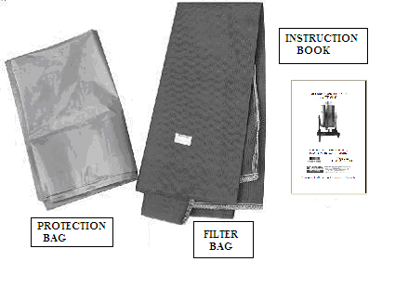

Brewcraft Ltd
(New Zealand, Australia, USA, & UK)

